AIM
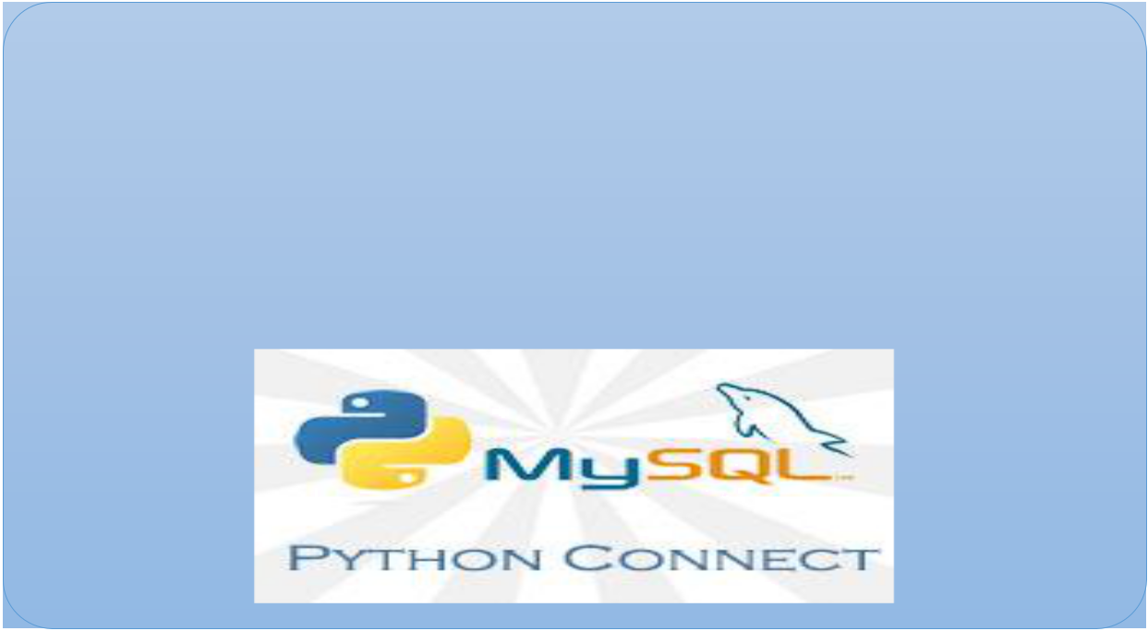
BANK OF K GROUP OF AGRO-INDUSTRIES
USING PYTHON, MYSQL AND TKINTER



CONTENT:
- INTRODUCTION
- MODULES USED
- CODING FILES
- OUTPUT SCREENSHOTS
- BIBLIOGRAPHY

Introduction

- What is Python?
The Python Programming Language is a recent, general-purpose and higher-level programming language. It has features for database programming also. This project aims on explaining how one can create a MySQL database from within a Python script and create a user interface software.

- Why Python?
Due to its open source nature, Python has been ported to many platforms. It is free and open source. It is available for free and runs on almost every current platform. Python provides interfaces to all major commercial databases. It can easily integrated with C, C++, COM, Java, MySQL, etc.

- What is MySQL?
MySQL is a freely available open source Relational Database Management System (RDBMS) that uses Structured Query Language (SQL). It provides you with a rich set of features that support a secure environment for storing, maintaining, and accessing data.

- Why MySQL?
It is an open source software and is easily portable. It is easy to use, manage and works quickly and efficiently. It is used to create databases, manage security of a database. It maintains integrity and reduces data redundancy.

- What is Tkinter?
Tkinter is the standard GUI library for Python. Python when combined with Tkinter provides a fast and easy way to create GUI applications. Tkinter provides a powerful object-oriented interface to the Tk GUI toolkit.

CODING FILES:
- Main.py
from tkinter import *
from PIL import ImageTk,Image
import pymysql
from tkinter import messagebox
from createaccount import *
from DepositAmount import *
from DisplayAccount import *
from Withdraw import *
from Contact import *
from TransferAmount import *
from DeleteAccount import *

db="bank"
global con
global cur
con = pymysql.connect(host="localhost",user="root",password='krish')
cur = con.cursor()
cur.execute("create database if not exists bank")
cur.execute("use bank")
cur.execute("create table if not exists bank_master(acno char(4) primary key,name varchar(30),city char(20),mobileno char(10),balance int(15))")
cur.execute("create table if not exists banktrans(acno char (4),amount int(6),dot date,ttype char(1),foreign key (acno) references bank_master(acno))")
con.commit()
root = Tk()
root.title("bank")
root.minsize(width=400,height=400)
root.geometry("1000x1000")
same=True
n=1.15
background_image =Image.open("p.jfif")
[imageSizeWidth, imageSizeHeight] = background_image.size
newImageSizeWidth = int(imageSizeWidth*n)
if same:
newImageSizeHeight = int(imageSizeHeight*n)
else:
newImageSizeHeight = int(imageSizeHeight/n)
background_image = background_image.resize((newImageSizeWidth,newImageSizeHeight),Image.ANTIALIAS)
img = ImageTk.PhotoImage(background_image)
Canvas1 = Canvas(root)
Canvas1.create_image(300,340,image = img)
Canvas1.config(bg="white",width = newImageSizeWidth, height = newImageSizeHeight)
Canvas1.pack(expand=True,fill=BOTH)
headingFrame1 = Frame(root,bg="dark blue",bd=5)
headingFrame1.place(relx=0.2,rely=0.1,relwidth=0.6,relheight=0.16)
headingLabel = Label(headingFrame1, text="BANK OF \n K GROUP OF AGRO-INDUSTRIES ", bg='medium spring green', fg='black', font=('Perpetua Titling MT',15))
headingLabel.place(relx=0,rely=0, relwidth=1, relheight=1)
btn1 = Button(root,text="Create\nAccount",bg='forest green', fg='black', font=('Arial',15), command=createacc)
btn1.place(relx=0.2,rely=0.3, relwidth=0.10,relheight=0.07)
btn2 = Button(root,text="Display\nAccount",bg='forest green', fg='black', font=('Arial',15), command=Display)
btn2.place(relx=0.2,rely=0.4, relwidth=0.10,relheight=0.07)
btn3 = Button(root,text="Deposit\nAmount",bg='forest green', fg='black', font=('Arial',15), command=DepositAmount)
btn3.place(relx=0.7,rely=0.3, relwidth=0.10,relheight=0.07)

btn4 = Button(root,text="Withdraw\nAmount",bg='forest green', fg='black', font=('Arial',15), command =Withdraw)
btn4.place(relx=0.7,rely=0.4, relwidth=0.10,relheight=0.07)
btn5 = Button(root,text="Transfer\nAmount",bg='forest green', fg='black', font=('Arial',15), command = TransferAmount)
btn5.place(relx=0.7,rely=0.5, relwidth=0.10,relheight=0.07)
btn6 = Button(root,text="Contact Us",bg='forest green', fg='black', font=('Arial',15), command = Us)
btn6.place(relx=0.9,rely=0.9, relwidth=0.10,relheight=0.07)
btn7 = Button(root,text="Delete\nAccount",bg='forest green', fg='black', font=('Arial',15), command=Delete)
btn7.place(relx=0.2,rely=0.5, relwidth=0.10,relheight=0.07)
root.mainloop()

- Createaccount.py
from tkinter import *
from PIL import ImageTk,Image
from tkinter import messagebox
import pymysql
def save():
acno= Info1.get()
name= Info2.get()
city= Info3.get()
mobileno= Info4.get()
balance= Info5.get()
insert="INSERT INTO bank_master(acno,name,city,mobileno,balance) VALUES ({},'{}','{}','{}','{}')".Format (acno ,name,city,mobileno,balance)
try:
cur.execute(insert)
con.commit()
messagebox.showinfo('Success',"Account Created successfully")
except:
messagebox.showinfo("Error","Can't Create Account\nContact Developer ")
root.destroy()
def createacc():
global Info1,Info2,Info3,Info4,Info5,Canvas1,con,cur,Table,root
root = Tk()
root.title("K Group of Agro-industries")
root.minsize(width=400,height=400)
root.geometry("600x500")
db="bank"
mypass = "12345"
con = pymysql.connect(host="localhost",user="root",password='krish',database=db)
cur = con.cursor()
Canvas1 = Canvas(root)
Canvas1.config(bg="dark green")
Canvas1.pack(expand=True,fill=BOTH)
headingFrame1 = Frame(root,bg="light green",bd=5)
headingFrame1.place(relx=0.25,rely=0.1,relwidth=0.5,relheight=0.13)
headingLabel = Label(headingFrame1, text="Create Account", bg='black', fg='white', font=('Courier',15))
headingLabel.place(relx=0,rely=0, relwidth=1, relheight=1)
labelFrame = Frame(root,bg='black')
labelFrame.place(relx=0.1,rely=0.4,relwidth=0.8,relheight=0.4)
lb1 = Label(labelFrame,text="Account No.: ", bg='black', fg='white')
lb1.place(relx=0.05,rely=0.2, relheight=0.08)
Info1 = Entry(labelFrame)
Info1.place(relx=0.3,rely=0.2, relwidth=0.62, relheight=0.08)
lb2 = Label(labelFrame,text="Name: ", bg='black', fg='white')
lb2.place(relx=0.05,rely=0.35, relheight=0.08)
Info2 = Entry(labelFrame)
Info2.place(relx=0.3,rely=0.35, relwidth=0.62, relheight=0.08)
lb3 = Label(labelFrame,text="City: ", bg='black', fg='white')
lb3.place(relx=0.05,rely=0.50, relheight=0.08)
Info3 = Entry(labelFrame)
Info3.place(relx=0.3,rely=0.50, relwidth=0.62, relheight=0.08)
lb4 = Label(labelFrame,text="Ph.No.: ", bg='black', fg='white')
lb4.place(relx=0.05,rely=0.65, relheight=0.08)
Info4 = Entry(labelFrame)
Info4.place(relx=0.3,rely=0.65, relwidth=0.62, relheight=0.08)
lb5 = Label(labelFrame,text="Balance: ", bg='black', fg='white')
lb5.place(relx=0.05,rely=0.80, relheight=0.08)
Info5 = Entry(labelFrame)
Info5.place(relx=0.3,rely=0.80, relwidth=0.62, relheight=0.08)
SubmitBtn = Button(root,text="SUBMIT",bg='#d1ccc0', fg='black',command=save)
SubmitBtn.place(relx=0.28,rely=0.9, relwidth=0.18,relheight=0.08)
quitBtn = Button(root,text="Quit",bg='#f7f1e3', fg='black', command=root.destroy)
quitBtn.place(relx=0.53,rely=0.9, relwidth=0.18,relheight=0.08)
root.mainloop()

- DisplayAccount.py
from tkinter import *
from PIL import ImageTk,Image
from tkinter import messagebox
import pymysql
db="bank"
con = pymysql.connect(host="localhost",user="root",password='krish',database=db)
def Display():
root = Tk()
root.title("bank")
root.minsize(width=400,height=400)
root.geometry("600x500")
Canvas1 = Canvas(root)
Canvas1.config(bg="dark green")
Canvas1.pack(expand=True,fill=BOTH)
headingFrame1 = Frame(root,bg="light green",bd=5)
headingFrame1.place(relx=0.25,rely=0.1,relwidth=0.5,relheight=0.13)
headingLabel = Label(headingFrame1, text="Bank Accounts", bg='black', fg='white', font=('Courier',15))
headingLabel.place(relx=0,rely=0, relwidth=1, relheight=1)
labelFrame = Frame(root,bg='black')
labelFrame.place(relx=0.25,rely=0.3,relwidth=0.5,relheight=0.6)
y = 0.25
Label(labelFrame, text="%-10s%-50s%-40s%-30s%- 20s"%( 'acno','name','city ','phno','balance'),bg='black',fg= 'white'). place(relx=0.07,rely=0.1)
Label(labelFrame, text="-------------------------------------------------------------------------------------------------------------------",bg='black',fg='white').place(relx=0.05,rely=0.2)
cur = con.cursor()
getBooks = "select * from bank_master"
try:
cur.execute(getBooks)
data=cur.fetchall()
con.commit()
for i in data:
Label(labelFrame, text="%-10s%-50s%-40s%-30s%-20s"%(i[0],i[1],i[2],i[3],i[4]),bg='black',fg='white').place
(relx=0.1,rely=y)
y += 0.1
except:
messagebox.showinfo("Failed to fetch files from database")
quitBtn = Button(root,text="Quit",bg='#f7f1e3', fg='black', command=root.destroy)
quitBtn.place(relx=0.4,rely=0.9, relwidth=0.18,relheight=0.08)
root.mainloop()

- DeleteAccount.py
from tkinter import *
from PIL import ImageTk,Image
from tkinter import messagebox
import pymysql
db="bank"
con = pymysql.connect(host="localhost",user="root",password='krish',database=db)
cur = con.cursor()
def d():
acno = Info1.get()
S="delete from banktrans where acno={}".format(acno)
try:
cur.execute(S)
con.commit()
messagebox.showinfo('Success',"deleted Successfully")
except:
messagebox.showinfo("invalid info",'check enetered info')
print(S)
root.destroy()
def Delete():
global Info1,Canvas1,con,cur,Table,root
root = Tk()
root.title("bank")
root.minsize(width=400,height=400)
root.geometry("600x500")
Canvas1 = Canvas(root)
Canvas1.config(bg="dark green")
Canvas1.pack(expand=True,fill=BOTH)
headingFrame1 = Frame(root,bg="light green",bd=5)
headingFrame1.place(relx=0.25,rely=0.1,relwidth=0.5,relheight=0.13)
headingLabel = Label(headingFrame1, text="Delete Account", bg='black', fg='white', font=('Courier',15))
headingLabel.place(relx=0,rely=0, relwidth=1, relheight=1)
labelFrame = Frame(root,bg='black')
labelFrame.place(relx=0.1,rely=0.3,relwidth=0.8,relheight=0.5)
lb1 = Label(labelFrame,text="Acconut No.: ", bg='black', fg='white')
lb1.place(relx=0.05,rely=0.35, relheight=0.08)
Info1 = Entry(labelFrame)
Info1.place(relx=0.3,rely=0.35, relwidth=0.62, relheight=0.08)
DELETEBtn = Button(root,text="Delete",bg='#d1ccc0', fg='black',command=d)
DELETEBtn.place(relx=0.28,rely=0.9, relwidth=0.18,relheight=0.08)
quitBtn = Button(root,text="Quit",bg='#f7f1e3', fg='black', command=root.destroy)
quitBtn.place(relx=0.53,rely=0.9, relwidth=0.18,relheight=0.08)
root.mainloop()

- DepositeAmount.py
from tkinter import *
from PIL import ImageTk,Image
from tkinter import messagebox
import pymysql
db="bank"
mypass = "12345"
con = pymysql.connect(host="localhost",user="root",password='krish',database=db)
cur = con.cursor()
def s():
acno = Info1.get()
amount = Info2.get()
dot = Info3.get()
tt ='D'
S="insert into banktrans values('{}','{}','{}','{}')".format(acno,amount,dot,tt)
M="update bank_master set balance=balance+{} where acno={}".format(amount,acno)
try:
cur.execute(S)
cur.execute(M)
con.commit()
messagebox.showinfo('Success',"deposited Successfully")
except:
messagebox.showinfo("Error","Can't Deposit Amount\ncontact developer'")
print(acno)
Info1.delete(0, END)
root.destroy()
def DepositAmount():
global Info1,Info2,Info3,Canvas1,con,cur,Table,root
root = Tk()
root.title("bank")
root.minsize(width=400,height=400)
root.geometry("600x500")
Canvas1 = Canvas(root)
Canvas1.config(bg="dark green")
Canvas1.pack(expand=True,fill=BOTH)
headingFrame1 = Frame(root,bg="light green",bd=5)
headingFrame1.place(relx=0.25,rely=0.1,relwidth=0.5,relheight=0.13)
headingLabel = Label(headingFrame1, text="Deposit Amount", bg='black', fg='white', font=('Courier',15))
headingLabel.place(relx=0,rely=0, relwidth=1, relheight=1)
labelFrame = Frame(root,bg='black')
labelFrame.place(relx=0.1,rely=0.3,relwidth=0.8,relheight=0.5)

lb1 = Label(labelFrame,text="Acconut No.: ", bg='black', fg='white')
lb1.place(relx=0.05,rely=0.35, relheight=0.08)
Info1 = Entry(labelFrame)
Info1.place(relx=0.3,rely=0.35, relwidth=0.62, relheight=0.08)
lb2 = Label(labelFrame,text="Amount: ", bg='black', fg='white')
lb2.place(relx=0.05,rely=0.50, relheight=0.08)
Info2 = Entry(labelFrame)
Info2.place(relx=0.3,rely=0.50, relwidth=0.62, relheight=0.08)
lb3 = Label(labelFrame,text="D.O.T.: ", bg='black', fg='white')
lb3.place(relx=0.05,rely=0.65, relheight=0.08)
Info3 = Entry(labelFrame)
Info3.place(relx=0.3,rely=0.65, relwidth=0.62, relheight=0.08)
SubmitBtn = Button(root,text="SUBMIT",bg='#d1ccc0', fg='black',command=s)
SubmitBtn.place(relx=0.28,rely=0.9, relwidth=0.18,relheight=0.08)
quitBtn = Button(root,text="Quit",bg='#f7f1e3', fg='black', command=root.destroy)
quitBtn.place(relx=0.53,rely=0.9, relwidth=0.18,relheight=0.08)
root.mainloop()

- WithdrawAmount.py
from tkinter import *
from PIL import ImageTk,Image
from tkinter import messagebox
import pymysql
db="bank"
con = pymysql.connect(host="localhost",user="root",password='krish',database=db)
cur = con.cursor()
def sav():
acno = info1.get()
amount = info2.get()
dot = info3.get()
t='W'
A = "insert into banktrans values('{}','{}','{}','{}')".format(acno,amount,dot,t)
B ="update bank_master set balance=balance-{} where acno={}".format(amount,acno)
try:
cur.execute(A)
cur.execute(B)
con.commit()
messagebox.showinfo('collect your money',"transection successfully done")
except:
messagebox.showinfo("Error","contect developer from'Contact Us'")
root.destroy()
def Withdraw():
global withdrawBtn,labelFrame,lb1,info1,info2,info3,quitBtn,root,Canvas1,status
root = Tk()
root.title("Library")
root.minsize(width=400,height=400)
root.geometry("600x500")
Canvas1 = Canvas(root)
Canvas1.config(bg="dark green")
Canvas1.pack(expand=True,fill=BOTH)
headingFrame1 = Frame(root,bg="light green",bd=5)
headingFrame1.place(relx=0.25,rely=0.1,relwidth=0.5,relheight=0.13)
headingLabel = Label(headingFrame1, text="Withdraw", bg='black', fg='white', font=('Courier',15))
headingLabel.place(relx=0,rely=0, relwidth=1, relheight=1)
labelFrame = Frame(root,bg='black')
labelFrame.place(relx=0.1,rely=0.3,relwidth=0.8,relheight=0.5)
lb1 = Label(labelFrame,text="Account No.: : ", bg='black', fg='white')
lb1.place(relx=0.05,rely=0.2)
info1 = Entry(labelFrame)
info1.place(relx=0.3,rely=0.2, relwidth=0.62)
lb2 = Label(labelFrame,text="Amount : ", bg='black', fg='white')
lb2.place(relx=0.05,rely=0.4)
info2 = Entry(labelFrame)
info2.place(relx=0.3,rely=0.4, relwidth=0.62)
lb3 = Label(labelFrame,text="D.O.T. : ", bg='black', fg='white')
lb3.place(relx=0.05,rely=0.6)
info3 = Entry(labelFrame)
info3.place(relx=0.3,rely=0.6, relwidth=0.62)
withdrawBtn = Button(root,text="Withdraw",bg='#d1ccc0', fg='black',command=sav)
wihdrawBtn.place(relx=0.28,rely=0.9, relwidth=0.18,relheight=0.08)
quitBtn = Button(root,text="Quit",bg='#aaa69d', fg='black', command=root.destroy)
quitBtn.place(relx=0.53,rely=0.9, relwidth=0.18,relheight=0.08)
root.mainloop()

- TransferAmount.py
from tkinter import *
from PIL import ImageTk,Image
from tkinter import messagebox
import pymysql
db="bank"
con = pymysql.connect(host="localhost",user="root",password='krish',database=db)
cur = con.cursor()
def sa():
acno = Info1.get()
hacno=Info2.get()
amount = Info3.get()
dot = Info4.get()
tt ='T'
S="insert into banktrans values('{}','{}','{}','{}')".format(hacno,amount,dot,tt)
M="update bank_master set balance=balance+{} where acno={}".format(amount,hacno)
A="insert into banktrans values('{}','{}','{}','{}')".format(acno,amount,dot,tt)
B="update bank_master set balance=balance-{} where acno={}".format(amount,acno)
try:
cur.execute(S)
cur.execute(M)
cur.execute(A)
cur.execute(B)
con.commit()
messagebox.showinfo('Success',"Transfer Successfully")
except:
messagebox.showinfo("invalid info","Can't Transfer Amount\nContact Developer from 'Contact Us'")
print(acno)
Info1.delete(0, END)
root.destroy()
def TransferAmount():
global Info1,Info2,Info3,Info4,Canvas1,con,cur,Table,root
root = Tk()
root.title("bank")
root.minsize(width=400,height=400)
root.geometry("600x500")
Canvas1 = Canvas(root)
Canvas1.config(bg="dark green")
Canvas1.pack(expand=True,fill=BOTH)
headingFrame1 = Frame(root,bg="light green",bd=5)
headingFrame1.place(relx=0.25,rely=0.1,relwidth=0.5,relheight=0.13)
headingLabel = Label(headingFrame1, text="Transfer Amount", bg='black', fg='white', font=('Courier',15))
headingLabel.place(relx=0,rely=0, relwidth=1, relheight=1)
labelFrame = Frame(root,bg='black')
labelFrame.place(relx=0.1,rely=0.3,relwidth=0.8,relheight=0.5)
lb1 = Label(labelFrame,text="Your Acconut No.: ", bg='black', fg='white')
lb1.place(relx=0.05,rely=0.35, relheight=0.08)
Info1 = Entry(labelFrame)
Info1.place(relx=0.3,rely=0.35, relwidth=0.62, relheight=0.08)
lb2 = Label(labelFrame,text="Host's Acconut No.: ", bg='black', fg='white')
lb2.place(relx=0.05,rely=0.50, relheight=0.08)
Info2 = Entry(labelFrame)
Info2.place(relx=0.3,rely=0.50, relwidth=0.62, relheight=0.08)
lb3 = Label(labelFrame,text="Amount: ", bg='black', fg='white')
lb3.place(relx=0.05,rely=0.65, relheight=0.08)
Info3 = Entry(labelFrame)
Info3.place(relx=0.3,rely=0.65, relwidth=0.62, relheight=0.08)
lb4 = Label(labelFrame,text="D.O.T.: ", bg='black', fg='white')
lb4.place(relx=0.05,rely=0.80, relheight=0.08)
Info4 = Entry(labelFrame)
Info4.place(relx=0.3,rely=0.80, relwidth=0.62, relheight=0.08)
SubmitBtn = Button(root,text="Submit",bg='#d1ccc0', fg='black',command=sa)
SubmitBtn.place(relx=0.28,rely=0.9, relwidth=0.18,relheight=0.08)
quitBtn = Button(root,text="Quit",bg='#f7f1e3', fg='black', command=root.destroy)
quitBtn.place(relx=0.53,rely=0.9, relwidth=0.18,relheight=0.08)

- Contact.py
from tkinter import *
from PIL import ImageTk,Image
from tkinter import messagebox
import pymysql
db="bank"
con = pymysql.connect(host="localhost",user="root",password='krish',database=db)
cur = con.cursor()
def Us():
global inf1,inf2,SubmitBtn,quitBtn,Canvas1,con,cur,root,labelFrame, lb1
root = Tk()
root.title("Library")
root.minsize(width=400,height=400)
root.geometry("600x500")
Canvas1 = Canvas(root)
Canvas1.config(bg="dark green")
Canvas1.pack(expand=True,fill=BOTH)
headingFrame1 = Frame(root,bg="dark blue",bd=5)
headingFrame1.place(relx=0.25,rely=0.1,relwidth=0.5,relheight=0.13)
headingLabel = Label(headingFrame1, text="Developer's detailes", bg='black', fg='white', font=('Courier',15))
headingLabel.place(relx=0,rely=0, relwidth=1, relheight=1)
labelFrame = Frame(root,bg='black')
labelFrame.place(relx=0.1,rely=0.3,relwidth=0.8,relheight=0.5)
lb1 = Label(labelFrame,text="NAME : Mr. Krish Nariya", bg='black', fg='white')
lb1.place(relx=0.05,rely=0.1)
lb2 = Label(labelFrame,text="CONTACT : krishnariya2003@gmail.com", bg='black', fg='white')
lb2.place(relx=0.05,rely=0.2)
lb3 = Label(labelFrame,text="CLASS : 12th SCI", bg='black', fg='white')
lb3.place(relx=0.05,rely=0.3)
lb4 = Label(labelFrame,text="NOTE : This Application is only developed for TRUSTED BANK OFFICIAL ONLY", bg='black', fg='white')
lb4.place(relx=0.05,rely=0.4)
quitBtn = Button(root,text="Quit",bg='#f7f1e3', fg='black', command=root.destroy)
quitBtn.place(relx=0.4,rely=0.85, relwidth=0.18,relheight=0.08)
root.mainloop()

SCREENSHORTS
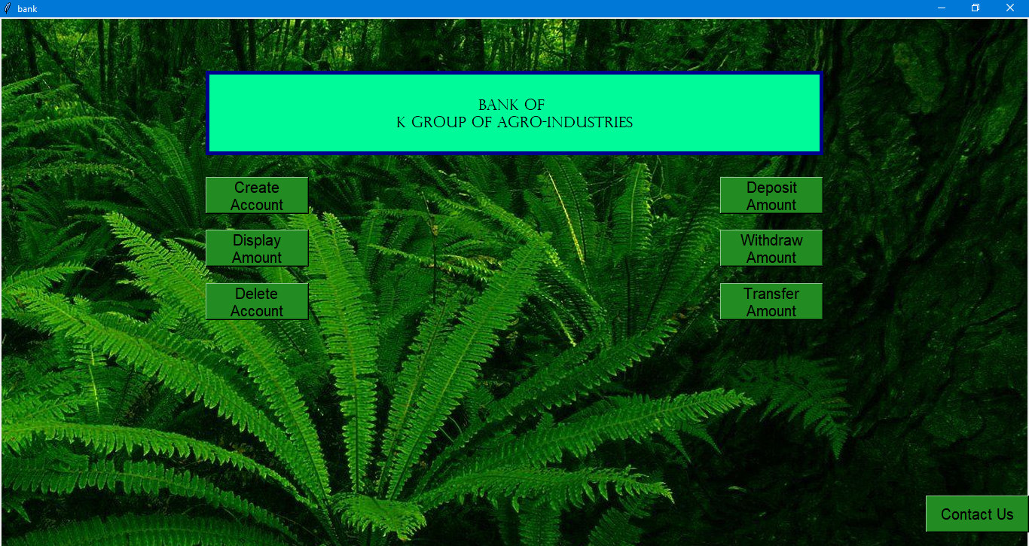

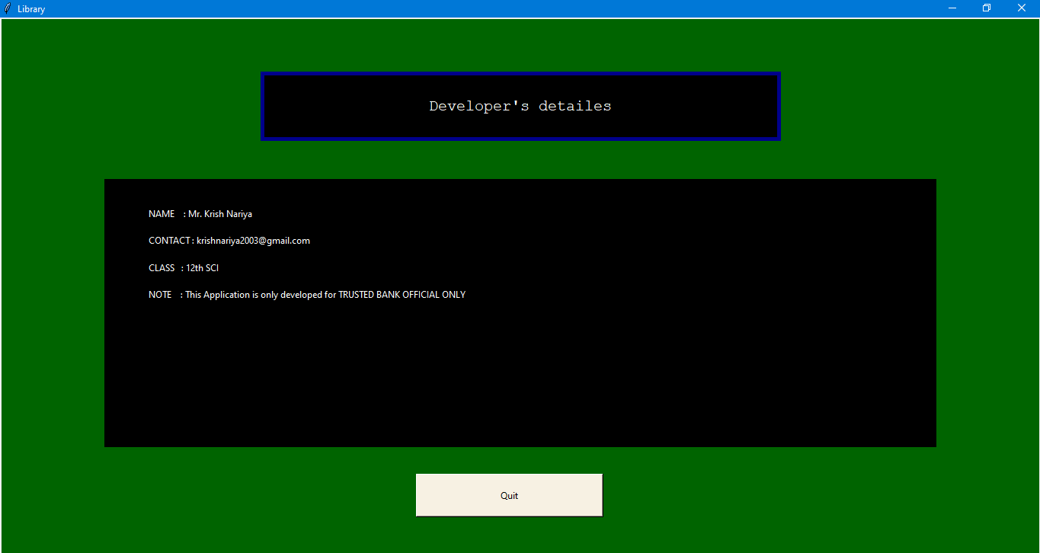
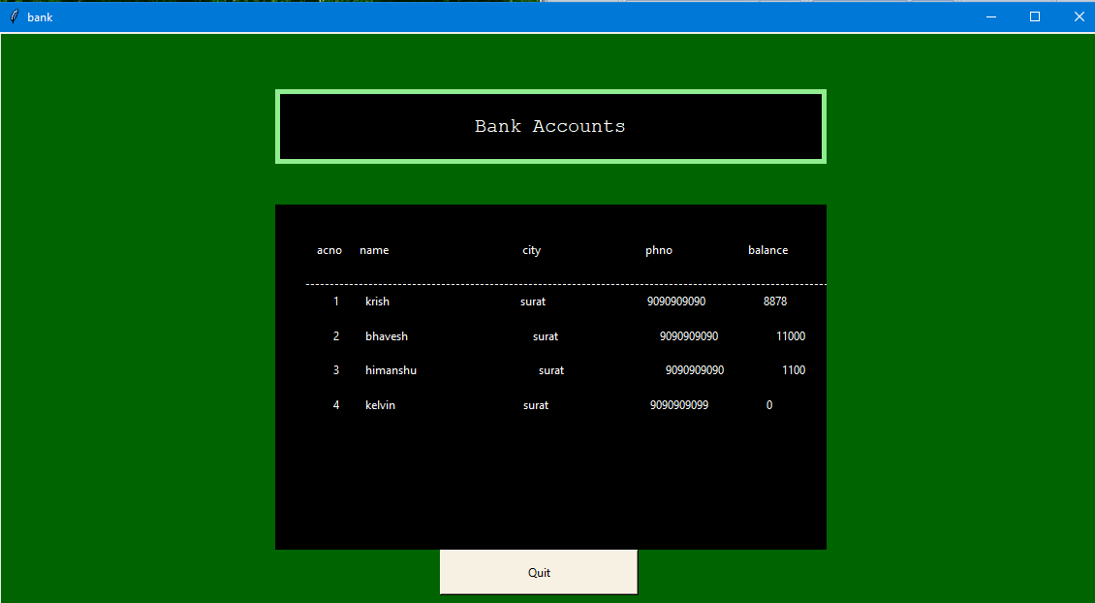

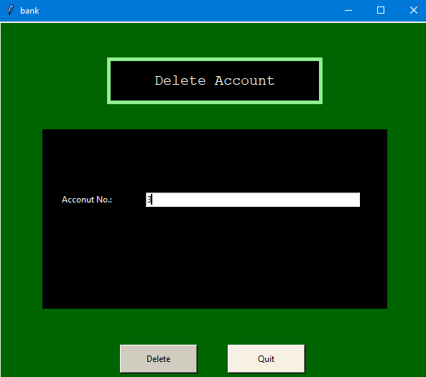

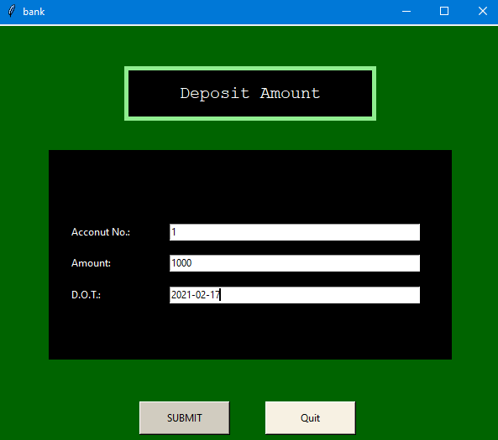

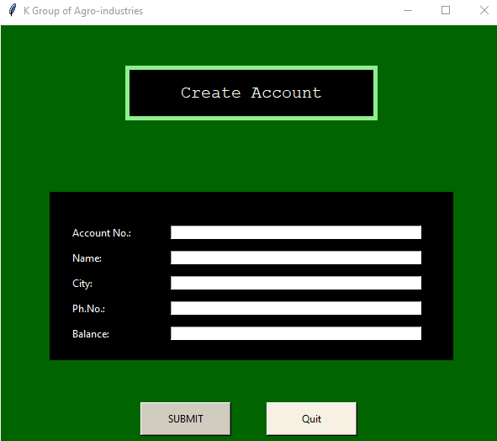
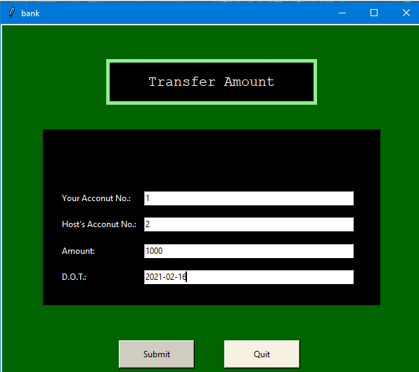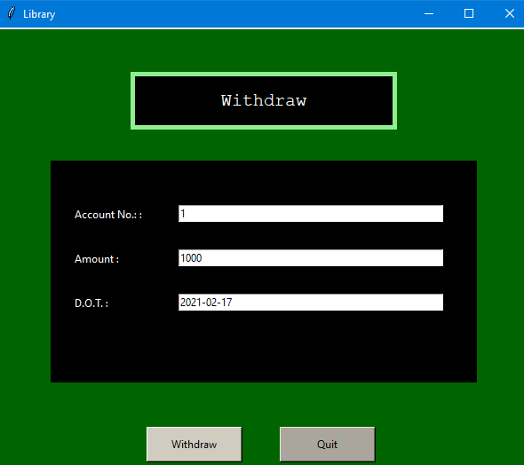

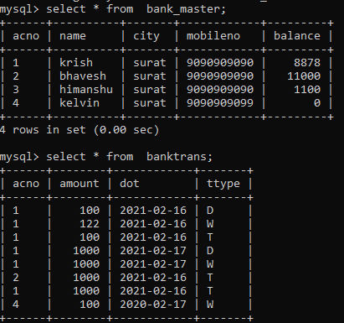

BIBLIOGRAPHY
- https://python-pillow.org/
- https://www.google.com/url?sa=t&rct=j&q=&esrc=s&source=web&cd=&cad=rja&uact=8&ved=2ahUKEwic4NHom_XuAhUOQd4KHfPcARMQFjAPegQICRAD&url=https%3A%2F%2Fwww.tutorialspoint.com%2Fpython%2Fpython_gui_programming.htm%23%3A~%3Atext%3DTkinter%2520is%2520the%2520standard%2520GUI%2CTkinter%2520is%2520an%2520easy%2520task.&usg=AOvVaw1eRlp2j0glVx4jrj6pzrVT

